**DAILY ONLINE ACTIVITIES SUMMARY**

|  |  |  |  |  |  |  |  |  |
| --- | --- | --- | --- | --- | --- | --- | --- | --- |
| **Date:** | **21/05/2020** | | | | | **Name:** | **Archana J C** | |
| **Sem & Sec** | **4th  ‘A’** | | | | | **USN:** | **4AL18CS011** | |
| **Online Test Summary** | | | | | | | | |
| **Subject** | | **Microcontroller and embedded system** | | | | | | |
| **Max. Marks** | | **30** | | **Score** | | | **15** | |
| **Certification Course Summary** | | | | | | | | |
| **Course** | **Python machine learning** | | | | | | | |
| **Certificate Provider** | | | **Great learning academy** | | **Duration** | | | **4-5 days** |
| **Coding Challenges** | | | | | | | | |
|  | | | | | | | | |
| **Status:** | | | | | | | | |
| **Uploaded the report in Github** | | | | | **Completed** | | | |
| **If yes Repository name** | | | | | **Yes** | | | |
| **Uploaded the report in slack** | | | | | **Yes** | | | |

Online Test Details: (Attach the snapshot and briefly write the report for the same)

Certification Course Details: (Attach the snapshot and briefly write the report for the same)

Coding Challenges Details: (Attach the snapshot and briefly write the report for the same)

ONLINE TEST : The test was easy and completed . There is no issues with the test .



ONLINE CERTIFICATION : I’m doing Python machine learning certification course from Great learning academy . Today I practiced some of the Python program in Jupyter . Then I undergone by practice program with are givien by the academy and I also learned about some of the data structures and how they are used in python .

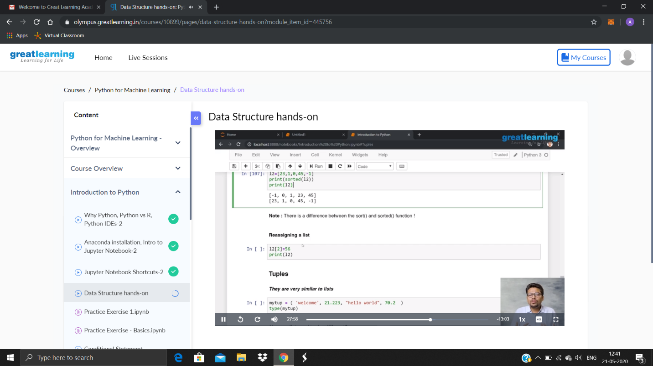

ONLINE CODING : Write a C program to implement SRTF process scheduling.

Input: A set of processes with their burst time and arrival time

Output: The processes scheduled based on the arrival time and a smaller burst time.

* The solution is uploaded in the github account .

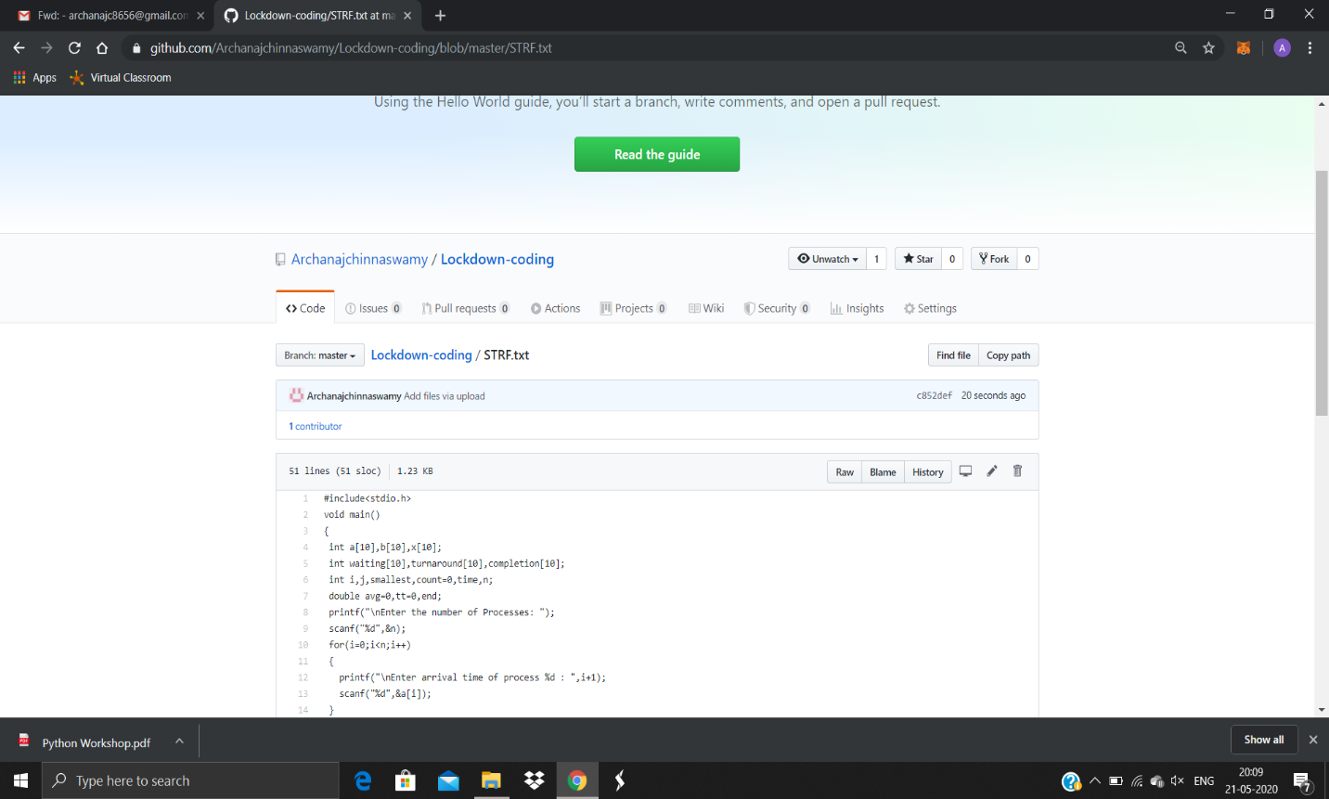

Write a C program to construct a singly linked list by removing duplicate elements in the sorted linked list

Description:

Take a sorted list and traverse the list. Compare the current node element with next adjacent node. If it is same then delete second element, if not retain. Finally print the resulting list.

Sample output:

Given list {1,2,2,3,3,3,4}

Resulting list{1,2,3,4}

* The solution was aploaded in github.

